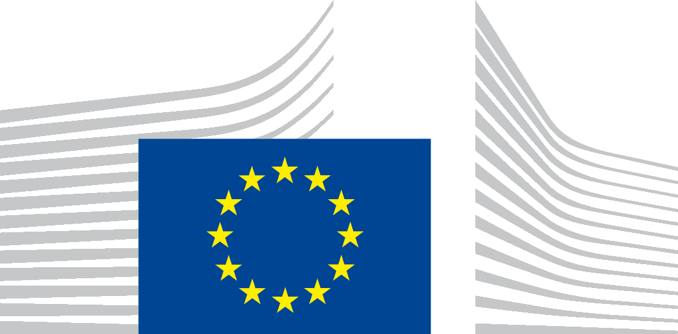 | EUROPEAN COMMISSION  DIRECTORATE-GENERAL FOR RESEARCH & INNOVATION  Directorate A - ERA & Innovation  A2 – ERA, Spreading Excellence and Research Careers
EXPERT GROUP ON THE ERA FORUM
23rd MEETING
24 May 2024, 09.00 – 16.15
Draft Agenda
Hybrid meeting
Centre Albert Borschette, Rue Froissart 36 (Brussels), Room 3.D

9.00 – 9.30 Welcome and introduction
- Adoption of the agenda
- Country reports on ERA Policy Platform
- ERA Conference

9.30 – 12.30 ERA governance and policy framework: Lessons learnt (EPA.1 and 2/MON.1/ADD.2, for discussion)
- Policy setting and governance aspects
- Monitoring mechanism
- National perspectives

LUNCH BREAK

14.00 – 15.00 Implementation of ERA Policy Agenda 2022-24 (EPA.2)
- Action 6: presentation on the final report from the PSF mutual learning exercise on tackling research and innovation foreign interference (for information)
- Action 12: update on progress, particular focus on technology infrastructures and pilot on aviation (for discussion)

15.00 – 16.00 Preparation of next ERA Policy Agenda 2025-27 (EPA.1, for discussion)
- Strengthening the Freedom of Scientific Research in the EU: Revised proposal for next ERA Policy Agenda
- A harmonised framework to support integrity and ethics in R&I in the face of emerging challenges: Revised proposal for next ERA Policy Agenda

16.00 – 16.15 Conclusions and next steps

